# Installing Jenkins in Linux and Creating a Freestyle Nginx Project

This guide covers the installation of Jenkins on a Linux system and the creation of a freestyle project to deploy Nginx.

## Prerequisites

Ensure your system is updated before proceeding:

sudo apt update && sudo apt upgrade -y

## Installing JDK 17

Jenkins requires Java to run. Install OpenJDK 17:

sudo apt install -y openjdk-17-jdk  
sudo update-alternatives --config java

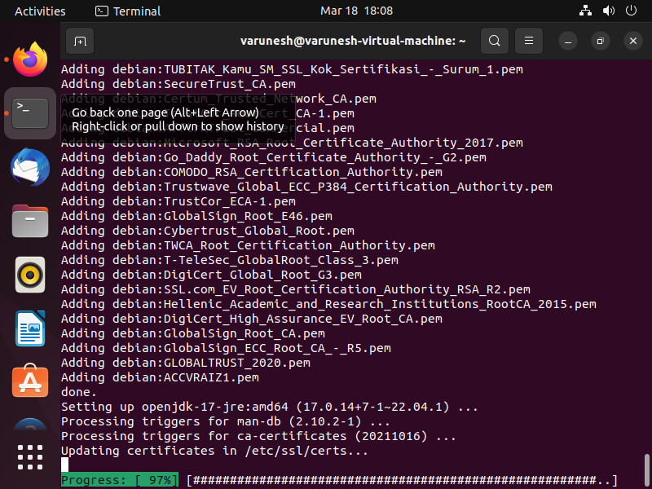

JDK

Selection

* After installation, select the appropriate Java version (java-17).

## Installing Jenkins

Download and install Jenkins from the official repository:

sudo wget -O /usr/share/keyrings/jenkins-keyring.asc \  
 https://pkg.jenkins.io/debian-stable/jenkins.io-2023.key  
  
echo "deb [signed-by=/usr/share/keyrings/jenkins-keyring.asc]" \  
 https://pkg.jenkins.io/debian-stable binary/ | sudo tee \  
 /etc/apt/sources.list.d/jenkins.list > /dev/null  
  
sudo apt-get update  
sudo apt-get install Jenkins

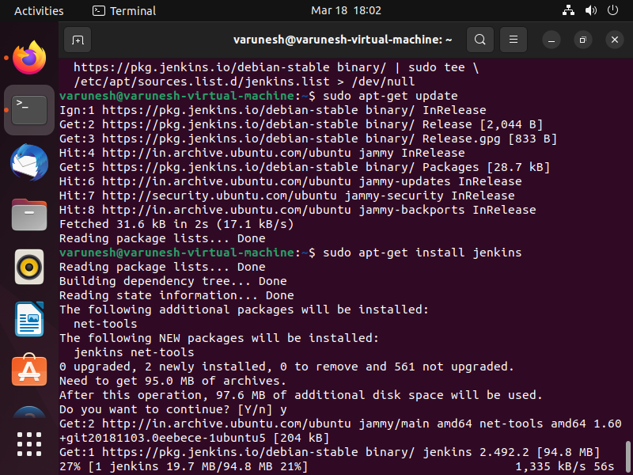

Jenkins Installed

## 

## Starting and Enabling Jenkins

Start Jenkins and enable it to run on system boot:

sudo systemctl enable jenkins  
sudo systemctl start jenkins  
sudo systemctl status jenkins

* Copy the password provided in the output for the next step.

## Jenkins Initial Setup

1. Open a browser and navigate to http://localhost:8080.
2. Enter the initial password from the previous step.

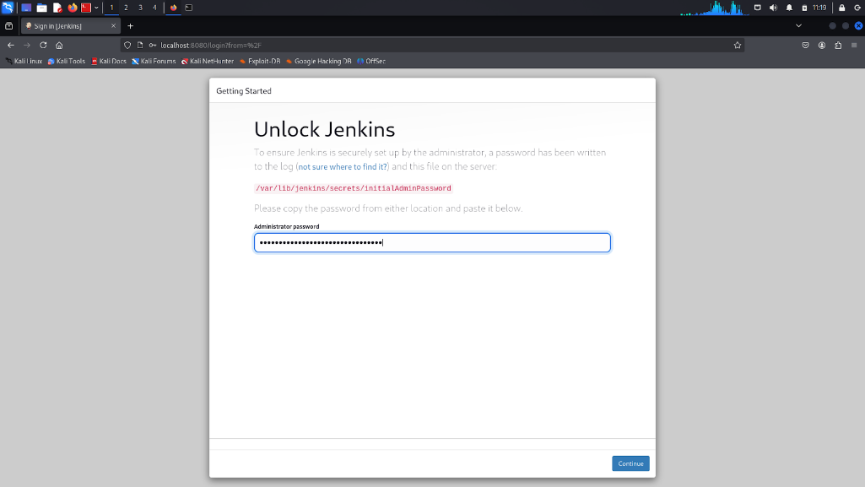

Jenkins Login

1. Click Continue.

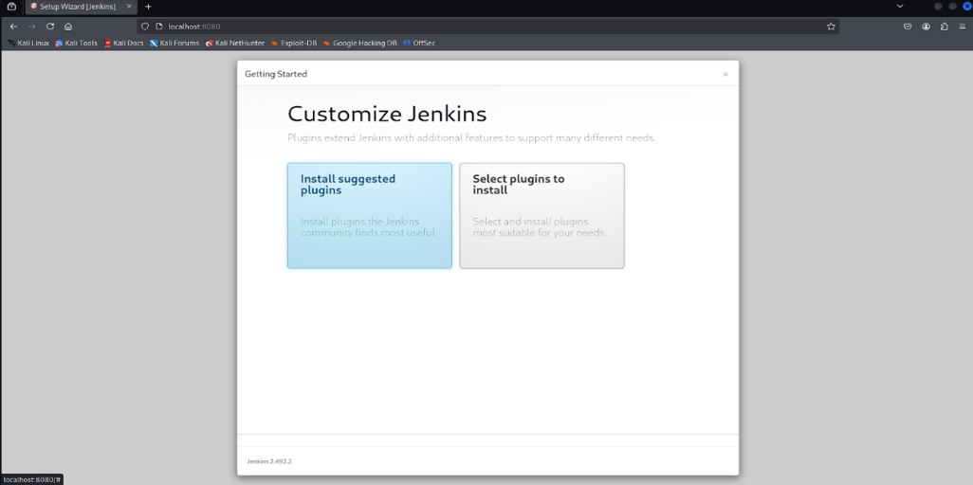

Continue Setup

1. Click Install Suggested Plugins.

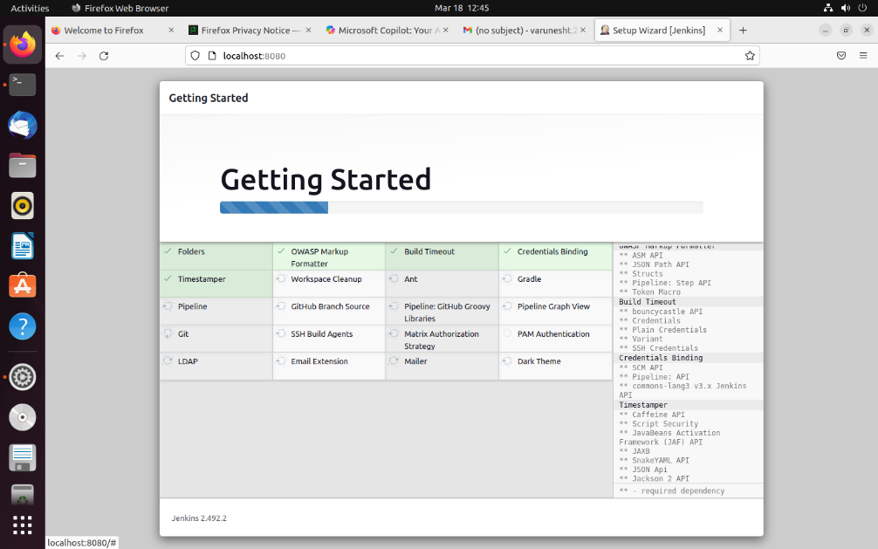

Installing Plugins

1. Wait for the plugin installation to complete, then click Start Jenkins.

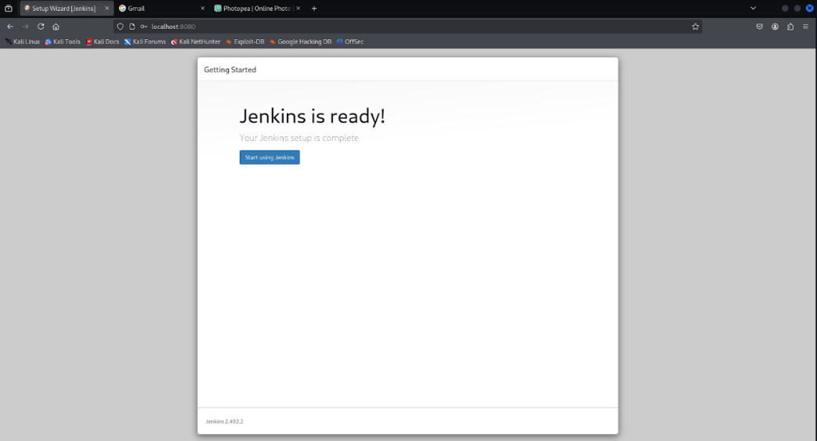

Start Jenkins

1. Create an admin user with a username and password.

**Note:** This username and password will be required for future logins.

1. Click Save and Continue.

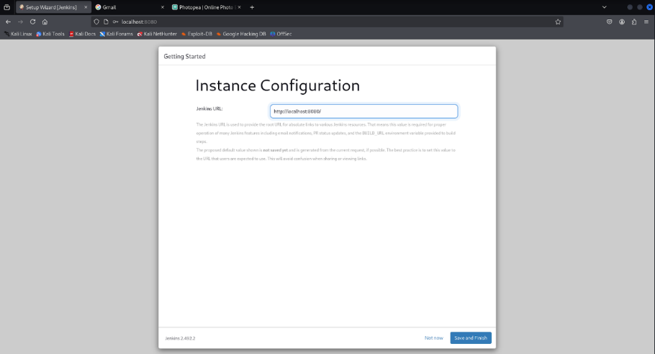

1. Keep the default Jenkins URL and click Save and Finish.

Jenkins Setup Complete

## Creating an Nginx Freestyle Project in Jenkins

1. Click Create a Job from the Jenkins homepage.

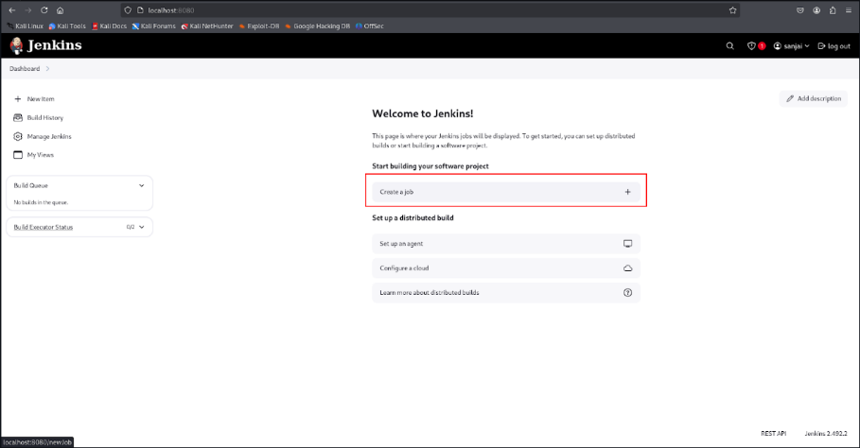

Create Job

1. Enter a project name.
2. Select Freestyle Project.
3. Click OK.

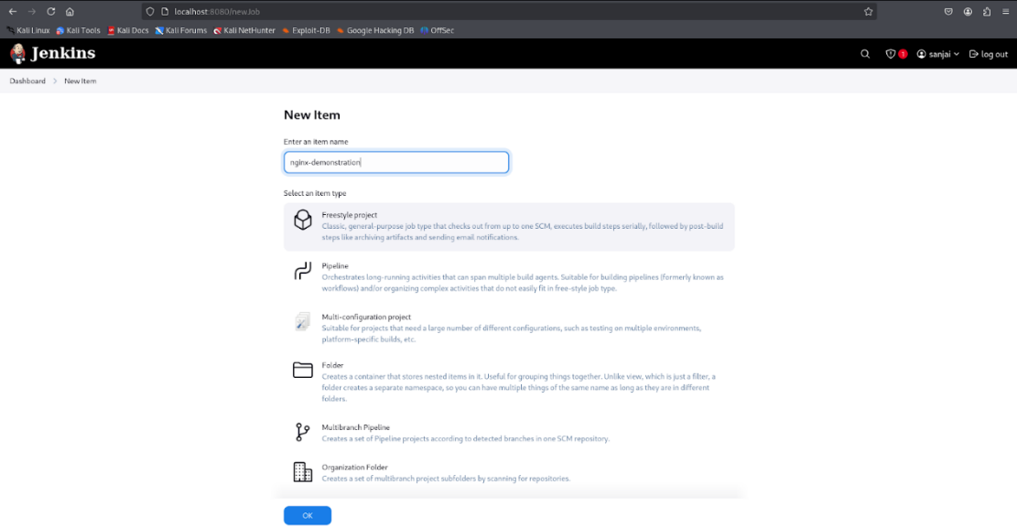

Freestyle Project

1. Scroll to Build Steps.
2. Click Add Build Step → Execute Shell.

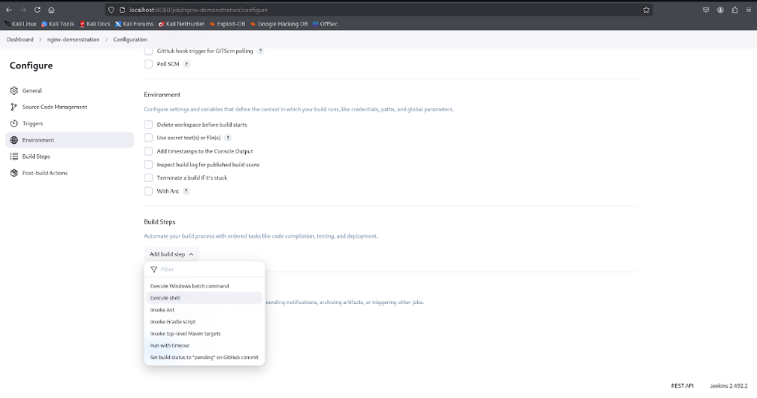

Build Step

1. Add the following shell script to install and configure Nginx:

#!/bin/bash  
# Update package lists  
sudo apt update -y  
  
# Install Nginx  
sudo apt install -y nginx  
  
# Start and enable Nginx  
sudo systemctl enable nginx.service  
sudo systemctl start nginx  
  
# Verify Nginx is running  
systemctl status nginx

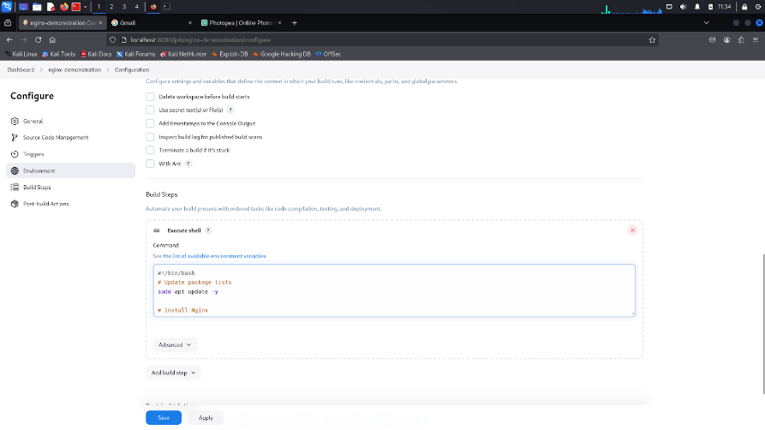

Shell Script

1. Click Build Now on the left panel.

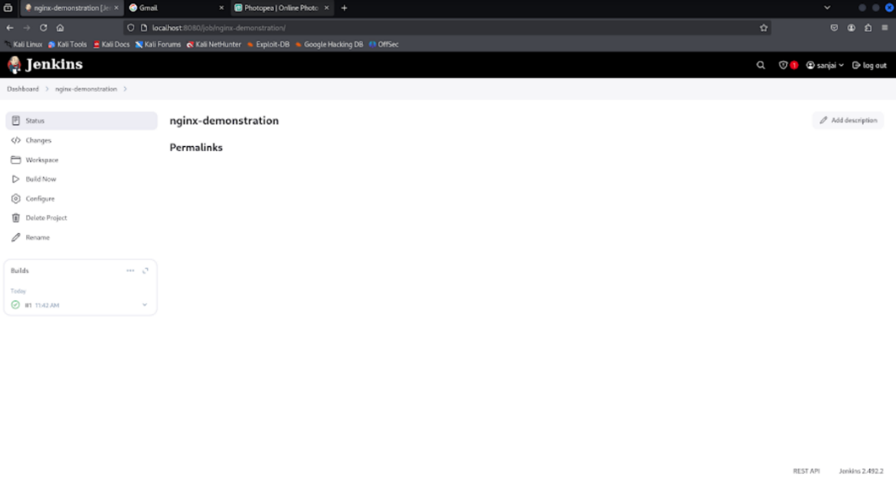

Build Now

## Verifying the Deployment

* Once the build is complete, click on the build entry under Builds.
* Click Console Output to review logs and confirm successful installation.

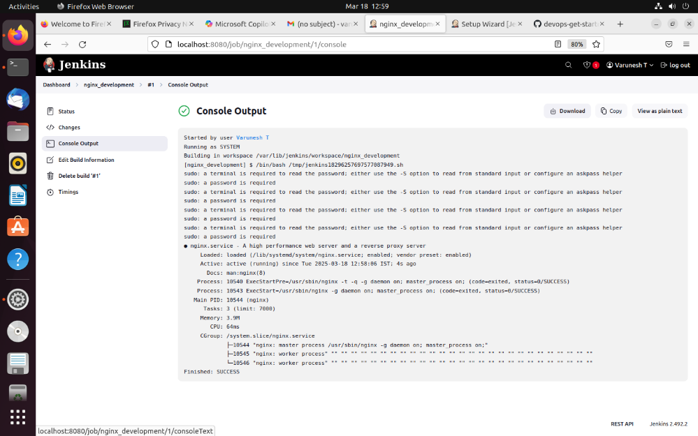

Console Output

Congratulations! You have successfully installed Jenkins and deployed Nginx using a freestyle project. Push this documentation to your Git repository for future reference.